After putting the yii2 advance file in the D: folder

**Create the Link to have a connection with the D: file to the htdocs.**

1. Open the Command prompt as Admin.
2. Enter 2 times the ‘cd..’ to access the c drive then enter “cd C://xampp/htdocs” to access the htdocs folder.
3. Then enter “mklink /d name of the folder path of the folder to be linked path of the destination” this will create the symbolic link. 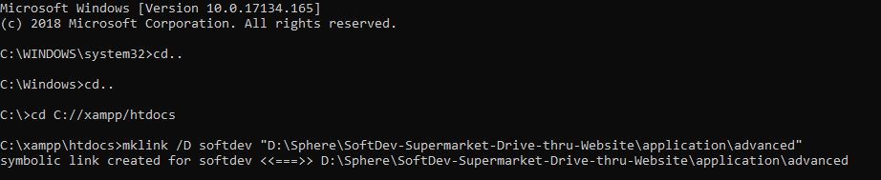
4. Enter 2 times the “cd..” and direct it in the D: folder. And enter “cd D:\Sphere\SoftDev-Supermarket-Drive-thru-Website\application\advanced” the folder\path of main folder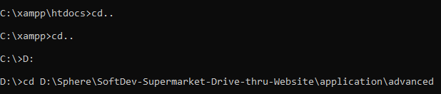
5. Enter “php init” and enter 0 for the development environment then enter “yes”

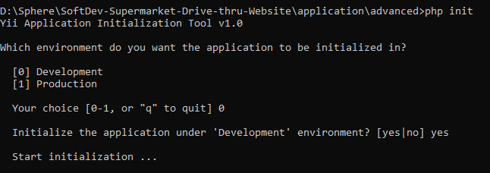

1. Enter “php yii migrate” and the is the last step of configuration of yii in the Windows 10.

